Word Template for a JCM2016 Paper
Author ONE¹, Author TWO² and Author THREE^{2*}
¹ Author one affiliation
² Authors two and three affiliation
* Corresponding author. Tel.: +0-000-000-0000 ; fax: +0-000-000-0000. E-mail address: author@institute.xxx

(NOTE: DO NOT ADD AUTHORS AND AFFILIATIONS FOR FIRST FULL PAPER SUBMISSION FOR 25th APRIL DEADLINE)
Abstract (250 WORDS MAX) JCM2016 conference aims to provide a special opportunity for the scientists to exchange their know-how and build up collaboration in the Interactive and Integrated Design and Manufacturing for Innovation. Each submission will be rigorously reviewed. All the accepted papers will be published on Lecture Notes in Mechanical Engineering, a book edited by Springer, indexed in SCOPUS. The format of your paper is defined in this MS Word 2003 sample and contains the prescribed styles necessary to be published by Springer. These styles are opened from the Format menu by activating the “Styles and Formatting…” option. All papers must be submitted electronically using the conference management system (EasyChair) and following the instructions you find at http://www.jcm2016ct.com/submission.asp. Please note that this document is formatted as an JCM2016 paper – all papers must fully comply with the formatting in this document.
Keywords: Please indicate four to five keywords, which will also be used for composing the Subject Index (written in 10 pt, justified).
1 Introduction
All papers should be restricted in length to a maximum of eight (8) pages, see directions at the conference website. Maximum two (2) extra pages will be allowed with an extra fee of € 10.00 per page. We aim to produce conference proceedings of a professional and consistent quality. We will be grateful for your help by carefully following the instructions outlined in this guide. This instruction itself is formatted as an JCM2016 final paper. The font used in this Template is Times. Do not use other similar fonts.
Author names are written in 10 pt, Alignment left. Use author style for automatic formatting. Affiliation of authors is written in 8.5 pt, Alignment left. Use Affiliation style. Abstract is written in 10 pt, justified. Use abstract style.
The paper should contain an abstract, an introduction, a main text, conclusions, and references.
The title of the paper should be written in 16 pt bold, Alignment left. Use title style. Section titles are 12pt bold, alignment left and are subtitle style. Subsection titles are 12pt bold italic, alignment left and subsubtitle style. The following standard numbering is prescribed: 2, 2.1, 2.2 etc. Instead of simply listing headings of different levels we recommend to let every heading be followed by at least a short passage of text.
The following are some examples of a typical equation, figure, table, citations and references. Please do not change the proposed formatting by introducing other styles or by changing this template.
1.1 Paragraphs and indents
Please note that the first line of text that follows a heading is indented (first line style), whereas the first lines of all subsequent paragraphs are (normal style). The text is 10 pt, justified. Spacing of the text is 12pt.
2 Equations
The same style as Normal text should be used in equation. Here, however Single space is recommended. Equations should be centered and numbered (equation style). Figure 1 presents the styles and sizes for equations. They should be referenced in the text as, for instance, (1). An example of equation is as follows
$G=\left(\begin{matrix}1 & 0 & 0 & 0 \\ a_{i} & 1 & 0 & 0 \\ 0 & 0 & \text{cos}(α_{i}) & −\text{sin}(α_{i}) \\ d_{i} & 0 & \text{sin}(α_{i}) & \text{cos}(α_{i})\end{matrix}\right) \text{.}$ (1)
3 Figures
Figures (at least 300 dpi) should be centered and referenced in the text as, for example, Figure 1. The font size in figures should be as Normal text (10 pt). Captions are placed under the figure, written in 8.5pt, using fig legend style. The example follows.

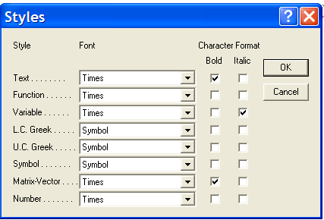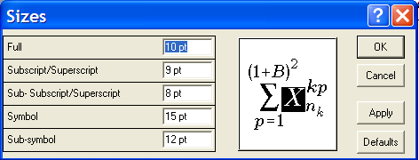
Fig. 1. Equation formatting.
4 Tables
Tables should be centered and referenced in the text as, for example, Table 1. The font size in tables should be table style (8.5pt). Captions are placed before the table (Table legend style).
Table 1. Please write your table caption here.
Description 1 | Description 2 | Description 3 | Description 4
Row 1, Col 1 | Row 1, Col 2 | Row 1, Col 3 | Row 1, Col 4
Row 2, Col 1 | Row 2, Col 2 | Row 2, Col 3 | Row 2, Col 4
Row 3, Col 1 | Row 3, Col 2 | Row 3, Col 3 | Row 3, Col 4
5 Referencing
The reference list should be in a citation order. A citation in the paper should have the form [1, 2, 3, 4] for a contribution in conference proceedings, monograph, journal article and on line document. Use references style (8.5 pt).
6 Submission of manuscript
Your manuscript must be uploaded by the conference management system EASYCHAIR. Please respect the deadlines.
We aim to make the publication of your paper as easy and free from errors as possible. In the first step (paper submission for peer reviewing, deadline 25th April 2016) we require you to submit your paper as a full paper electronically in PDF format. Please leave out names and affiliations of the authors as well as the contact details in this version. You will be notified of acceptance of your full paper and any changes required by the reviewers on or shortly after 20th May 2016.
In the second step (submission of final paper – deadline 10th June 2016) we will ask you to provide a full paper version (for publication) in Word format. This version will address the changes required by the reviewers and will include author names and affiliations.
Acknowledgments The research work reported here was made possible by ... Use acknowledgement style.
References
1. Van Wezel W. and Jorna W.J. Paradoxes in planning. Engineering Applications of Artificial Intelligence, 2001, 14(3), 269-286.
2. Angell I.O. and Straub B. Rain-Dancing with Pseudo-Science. Cognition, Technology & Work, 1, 1999, pp.179-196.
3. Crisfield M.A. Non-linear Finite Element Analysis of Solids and Structures, Volume 2: Advanced Topics, 1997 (John Wiley & Sons, Chichester).
4. Eppinger S.D. and Salminen V.K. Patterns of product development interactions. In International Conference on Engineering Design, ICED'01, Vol. 1, Glasgow, August 2001, pp.283-290 (Professional Engineering Publishing, Bury St Edmunds).

